4.1.1 SET OPERATIONS
ALGORITHM
Step 1: Start
Step 2: Read elements of Set A
Step 3: Read elements of Set B
Step 4: Compute Union of A and B
Step 5: Compute Intersection of A and B
Step 6: Compute Difference (A − B)
Step 7: Display Union, Intersection, and Difference
Step 8: Stop
FLOWCHART
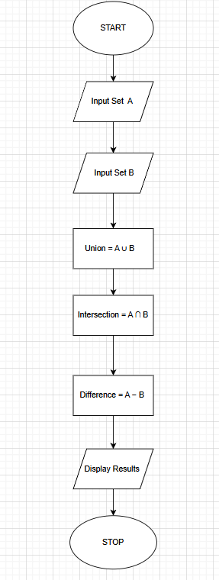
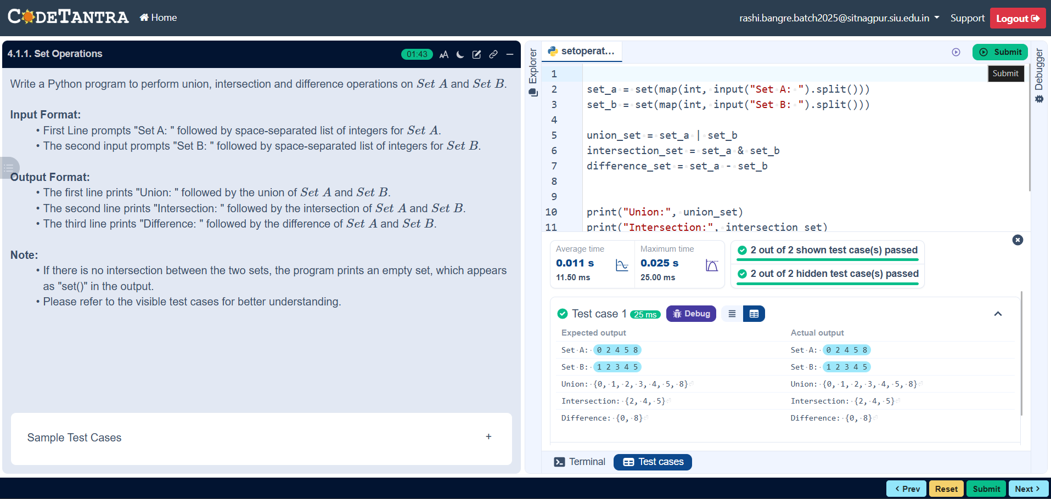
PROGRAM

